**LOW LEVEL DESIGN**

**(Analyse International Debt Statistics)**

|  |  |
| --- | --- |
| **Written By** | **Dabir Hundekari** |
| **Document Version** | **1** |
| **Last Revised Date** |  |

**DOCUMENT CONTROL**

**Change Record:**

|  |  |  |  |
| --- | --- | --- | --- |
| **VERSION** | **DATE** | **AUTHOR** | **COMMENTS** |
| 1 | 01/06/2023 | Dabir Hundekari | Introduction, Architecture and Unit Test Cases are defined. |
|  |  |  |  |
|  |  |  |  |

**Reviews:**

|  |  |  |  |
| --- | --- | --- | --- |
| **VERSION** | **DATE** | **AUTHOR** | **COMMENTS** |
|  |  |  |  |

**Approval Status:**

|  |  |  |  |  |  |
| --- | --- | --- | --- | --- | --- |
| **VERSION** | **REVIEW DATE** | **REVIEWED BY** |  | **APPROVED BY** | **COMMENTS** |
|  |  |  |  |  |  |

**Table of Contents**

INTRODUCTION4

What is Low-Level Design Document4

Scope4

Architecture5

Power BI Server Architecture…………………………………………….5

Architecture Description……………………………………………………8

Data Description…………………………………………………………….....8

Fetching and Loading Data in Power Bi Desktop………………..8

Deployment……………………………………………………………………10

Unit test cases12

1. **Introduction**
2. **What is Low Level Design?**

The goal of the LDD or Low-level design document (LLDD) is to give the internal logic design of the actual program code for the House I Prediction dashboard. LDD describes the class diagrams with the methods and relations between classes and programs specs. It describes the modules so that the programmer can directly code the program from the document.

1. **Scope**

Low-level design (LLD) is a component-level design process that follows a step-by-step refinement process. The process can be used for designing data structures, required software architecture, source code and ultimately, performance algorithms. Overall, the data organization may be defined during requirement analysis and then refined during data design work.

1. **Architecture**

**Power BI Server Architecture**

The Power BI service architecture enables the user to create and access various reports and dashboards from the client platforms. The user needs to request or interact with the Power BI service to get data on the Power BI.

The Power BI implementation includes two major clusters. Such as a Web Front End (WFE) cluster, and a Back-End cluster.

Here, we look at the working of different components of Power BI architecture together.

To start this, we need to begin with the source of data that flows into the Power BI components. Power BI gets these data from different sources such as files, on-cloud, on-premise databases, or from direct connections.

**On-Premise**

Power BI Desktop is a development, authorizing, and publishing tool that allows users to import data from different data sources. They can use it to create and publish various reports on a Power BI Service or Report Server. These reports are visualized for making better decisions.

**On-Cloud**

The Power BI Gateway is an important part of Power BI Architecture that makes a secure way to transfer data or information from on-premise to cloud data sources. Besides, the Cloud architecture of Power BI includes various components. Such as; datasets, dashboards, reports, Power BI Embedded, and Premium. Moreover, these on-cloud data sources are connected to various Power BI tools as well.

**Power BI components**

Power BI architecture includes several components that work together. These components are an important part of [Power BI](https://onlineitguru.com/blogger/what-is-power-bi-slicer-how-it-is-different-from-filters)that delivers its capabilities. Now, we will discuss in detail the various components of Power BI architecture.

**a) Data Sources**

There are many data sources that Power BI uses to extract data and transform it into meaningful insight. The data sources that support Power BI are databases, file types, Azure, online services, other services (HDFS, ODBC, Spark, R Script), etc.

**b) Power BI Desktop**

This is free software that allows users to connect, transform, and visualize information or data on the desktop. Besides, the user can connect to different sources of data using Power Desktop and combine all the data into a data model. This enables the user to create a variety of graphical images to share with other people within the organization for records. Moreover, most users working on various BI projects use this feature to generate reports.  Later, they also use Power BI to share these reports with others.

**c) Power BI Mobile**

Using these mobile applications the user can connect with the information anywhere and anytime. It supports various platforms such as iOS, Windows, Android, etc. Moreover, these applications are useful for visualizing various dashboards and reports easily.

There are many arrangements by Power BI for mobile apps for different gadgets. It offers different models and services for different types of devices and their usage. All services are compatible with every device and also update regularly. These apps can be configured with custom solutions that provide better engagement and service. Furthermore, there many apps designed for these gadgets like iOS, Android, Tablets, etc.

**d) Power BI Report Server**

Under Power BI architecture, the Report Server component is an on-premise platform similar to Power BI Service. Moreover, the Report Server allows users to create various dashboards and reports to share with others following proper security protocols.

**e) Power BI Gateway**

The Power BI gateway is useful to maintain information freshly by creating a link to on-site data sources without moving the information. Moreover, by linking to on-site information sources, the user can maintain information afresh using the on-site gateways. Here, the user can transfer his precious data securely between the cloud services as well as on-premise.

**f) Power View**

The Power BI View in the Power BI architecture components offers interactive visualization. It allows the user to use drag and drop facilities to create visualizations quickly and attractively.

**g) Power Pivot**

The element Power Pivot helps to store the information within memory and enables users to store highly compressed data. It also allows for faster aggregation of data and computation. Moreover, Power Pivot is also useful within an Excel workbook that helps to build data models. The advantage of this component is that it can load data itself or power query helps to load data into it. Furthermore, it is similar to the SSAS model like a server-based version of the Power Pivot.

Power Pivot has no limit on the number of lines alike in MS Excel. Some features make it a unique tool for users to do some tasks. Such as loading limitless tables, data compression for the data model, fully supported database engine, faster data transformation, etc.

**h) Power Q&A**

The Power Q&A is the Power BI architecture feature that allows users to explore data in their own specific words. Here, the users can use natural language to ask a query and get the answer for the same. Moreover, this is the fastest way to get any query answered within a limited time. It’s an interactive path with query solution and visualization of the answer to the user. There are many ways to use Q&A within Power BI.

The Power Q&A within the Power BI architecture is useful in the Power BI Service dashboards, reports in the Desktop model, etc. Moreover, in mobile apps also this service is useful.

**3. Architecture Description**

**3.1 Data Description**

The Dataset contains list of debt taken by countries along with country codes and indicator names.

1. country_name = Name of the country who are payable to debts.
2. country_code = Code name of each country.
3. Indicator_name = Represents the status of debt taken.
4. Indicator_code = Unique code for each indicator_name
5. Debt = Amount of debt ($USD) taken.

**3.2 Fetching and Loading data in BI Desktop**

Data is downloaded from [Data Catalog (worldbank.org)](https://datacatalog.worldbank.org/dataset/international-debt-statistics) and loaded into Power BI Desktop.

**Step 1: Connecting Data**

Launch Power BI on your workstation and Select **Get Data** from the Home tab.This will launch dialogue box where you browse the csv file to load the data into Power BI desktop.

**3.3 Deployment**

Once you’ve completed your dashboard, follow the following steps.

1. Click to Publish.
2. Enter your Email ID.
3. Search and Select your Destination.

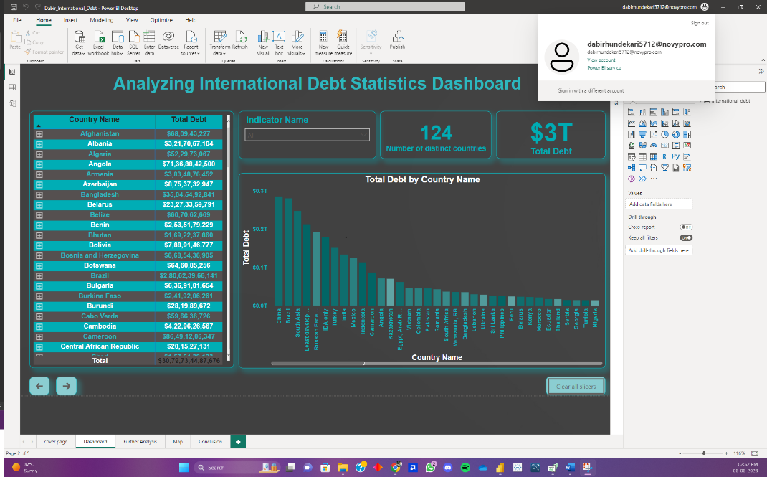

Enter your email address from which you want to create workspace account where you can store all your reports.

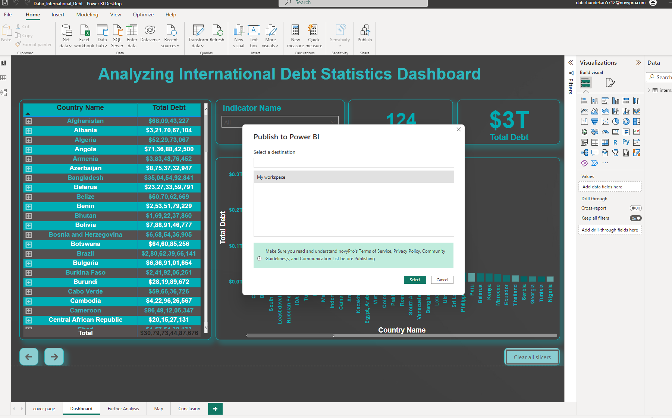

Select the workspace where you want to store the report. You can create n number of workspace to categorise your reports.

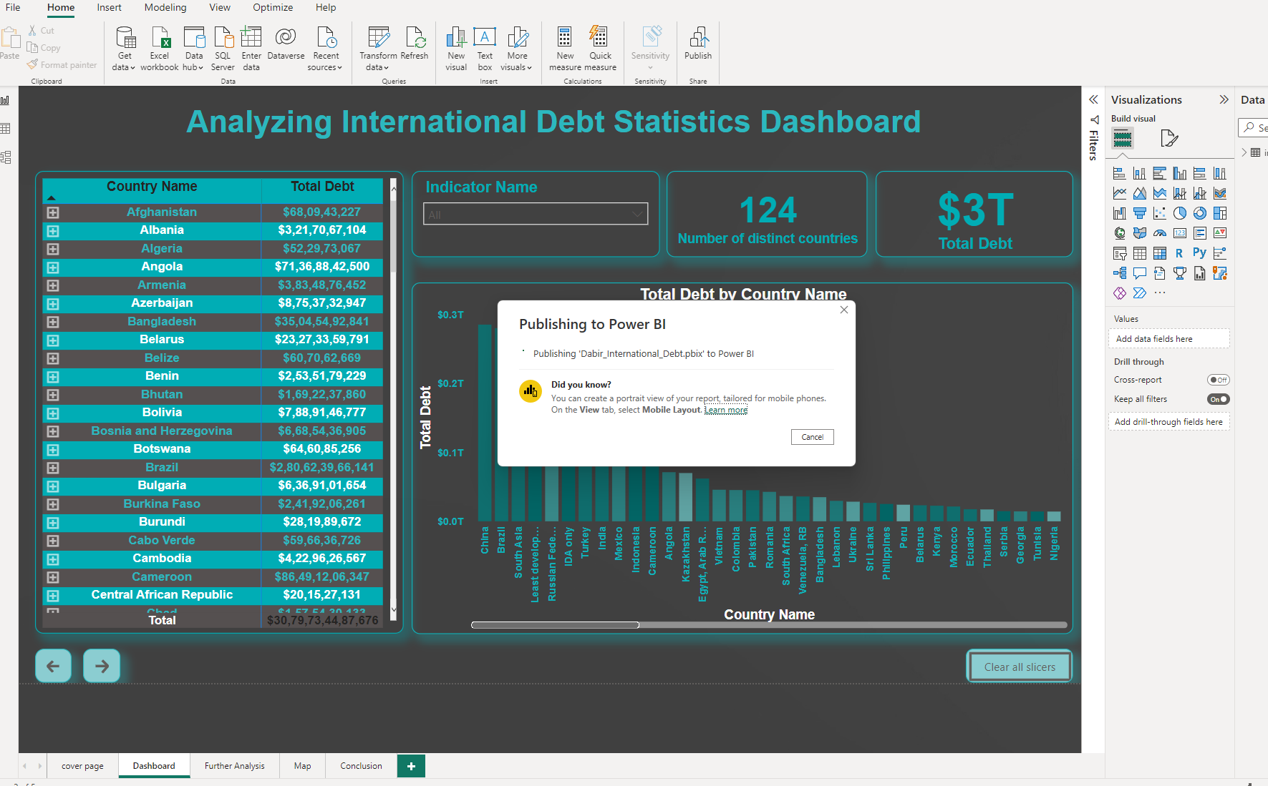

After Selecting the report will automatically get stored and published in your Microsoft Power BI account.

1. **Unit Test Cases**

|  |  |
| --- | --- |
| **TEST CASE DESCRIPTION** | **EXPECTED RESULTS** |
| World Bank’s Debtor’s Chart | When clicked on the chart, Whole page visuals interact with the click.  Clicking the name of a country presents the visualisation of country’s data. |
| World Bank’s International Debt Matrix | When clicked on the drill down and slicing option, report will show the countries name or the indicator name respect to the loan being borrowed to them. |
| Q & A | Select the questions made by Power BI Built-in AI Tools to get the most anticipated answers. |
| World Map | Drill down or up to visualise the data based on country name or indicators. |